Colors Challenge!

Diann Reischman
Grand Valley State University
reischmd@gvsu.edu

Published: June 2013

Overview of Lesson
In this activity, students collect data from an experiment designed to investigate whether or not the ability to name the color of printed ink is challenged when the word written with the ink is the name of a color. Students are asked to design the experiment to investigate this. Numeric summaries (mean and five-number summary) and comparative boxplots are used to summarize the collected data. Conclusions are drawn about the difficulty of naming a color when it is displayed in this manner.

GAISE Components
This investigation follows the four components of statistical problem solving put forth in the Guidelines for Assessment and Instruction in Statistics Education (GAISE) Report. The four components are: formulate a question, design and implement a plan to collect data, analyze the data by measures and graphs, and interpret the results in the context of the original question. This is a GAISE Level B activity.

Common Core State Standards for Mathematical Practice
- Make sense of problems and persevere in solving them.
- Reason abstractly and quantitatively.
- Construct viable arguments and critique the reasoning of others.
4. Model with mathematics.
5. Use appropriate tools strategically.

Common Core State Standard Grade Level Content (High School)
S-ID. 1. Represent data with plots on the real number line (dot plots, histograms, and box plots).
S-ID. 2. Use statistics appropriate to the shape of the data distribution to compare center (median, mean) and spread (interquartile range, standard deviation) of two or more different data sets.
S-ID. 3. Interpret differences in shape, center, and spread in the context of the data sets, accounting for possible effects of extreme data points (outliers).
S-IC. 1. Understand statistics as a process for making inferences about population parameters based on a random sample from that population.
S-IC. 5. Use data from a randomized experiment to compare two treatments; use simulations to decide if differences between parameters are significant.

NCTM Principles and Standards for School Mathematics
Data Analysis and Probability Standards for Grades 9-12
Formulate questions that can be addressed with data and collect, organize, and display relevant data to answer them:
- understand the differences among various kinds of studies and which types of inferences can legitimately be drawn from each;
- know the characteristics of well-designed studies, including the role of randomization in surveys and experiments;
- understand the meaning of measurement data and categorical data, of univariate and bivariate data, and of the term variable;
- understand histograms, parallel box plots, and scatterplots and use them to display data;
- compute basic statistics and understand the distinction between a statistic and a parameter.
Select and use appropriate statistical methods to analyze data:
- for univariate measurement data, be able to display the distribution, describe its shape, and select and calculate summary statistics;
- display and discuss bivariate data where at least one variable is categorical.

Prerequisites
Students will have knowledge of calculating numeric summaries for one variable (mean and five-number summary). Students will have knowledge of how outliers may affect numeric summaries. Students will have knowledge of how to construct and interpret comparative boxplots.

Learning Targets
Students will have a basic understanding of how to design a simple experiment with a control group. Students will be able to calculate numeric summaries and construct comparative boxplots for two data sets. Students will be able to determine what data values would be considered to be outliers. Students will be able to compare two data sets using their calculated numeric summaries and comparative boxplots. Students will understand how to compare their results to hypothesized results.

Time Required
One class period.

Materials Required
- Twelve cards (per group; the cards should be the same for all groups), each with one word not related to a color written on it; each word should be written with one color of ink and the colors should vary from one card to another. For example:
TABLE
JULY
RUN

- Twelve cards (per group; the cards should be the same for all groups), each with the name of a color written on it; each word should be written with one color of ink that does not match the color name, and there should be the same number of each color as there are for the non-color words, e.g., if there are two cards written in purple ink for non-color words then there should be two cards written in purple ink for the color name cards. For example:

BLUE
GREEN
RED

- Pencils (one per group).
- Stopwatches (one per group).
- Graphing calculators (one per group).

Instructional Lesson Plan

The GAISE Statistical Problem-Solving Procedure

I. Formulate Question(s)
Begin the lesson by discussing the nature of the experiment. A psychology researcher wishes to know how people react when two conflicting stimuli are presented to them. In his research, he experimented by asking people to say the color of ink used to print the names of colors. He found that people have a tendency to read the text and have difficulty ignoring the word itself in order to say the color of the ink.

Tell the students that they will be conducting an experiment of this nature and will analyze the data collected. Ask students to write some questions of interest that may help determine if people have the difficulty described by the psychology researcher. Some possible questions they may ask:
1. Is it difficult to say the ink color for a word that is the name of a color?
2. What is the average time to say an ink color for a color name?
3. What is the average time to say an ink color for words that are not colors?
4. What are the fastest (minimum) time and slowest (maximum) time students in the class take to say the ink color?
5. Is there a difference between males and females with respect to how quickly they can say the ink color?

II. Design and Implement a Plan to Collect the Data
Tell the students that they will be conducting an experiment of a nature similar to what the psychologist did, and that they will analyze the data collected. Ask students to think about how they can perform this type of experiment within the classroom. Some possible things they should consider:
- What materials could be used to present the names of colors?
- How could they measure how long it takes for someone to name the ink color?
- What can they do to determine whether or not people do have difficulty saying the ink color? Can they compare the response times for the color words to some other times?
- How can randomization be used?

After discussion of possible ways to conduct the experiment, explain how it will be carried out in the classroom.

Break the students into groups of at least four students. Give each group two sets of 12 cards, one set with words not related to colors printed in colored ink, and the other set with names of colors printed in non-matching ink colors. Explain that they will be shown the cards like flash cards, and they must name the ink color. The times to say the ink color will be compared for the two different types of words. Within the student group, one person will hold and show the cards, one person will say the ink color, a third person will use the stopwatch to time how long it takes the student to respond, and the fourth person will write the times down on the data collection sheet. Tasks should rotate so that each person in the group has a set of response times.

Before starting, directions on how to use the stop watch should be given so that timing is consistent for all groups. One method would be to have the person showing the cards always say “start” when showing a new card, at which point the person timing presses start. As soon as the person saying the color finishes saying the correct color, the person will stop the stopwatch.

Students also need to consider the order in which the cards should be shown. Ask the students how they think the cards should be shown. For example, should all of the non-color words be shown first, followed by all of the color word cards; or should it alternate between non-color words and color names? Students will likely recognize that showing all of one type of word first followed by all of the other type is not ideal. This method could create bias as the students may do better on later cards, i.e., there may be a learning effect. Students are less likely to recognize that alternating between the two types of words is not the best method since the person saying the ink color will have some idea of what to expect with each next card, knowing whether it will be a non-color word or a color name. Ideally, randomization should be used to determine which card should be shown. To simulate randomization, students will shuffle the cards several times so that they are mixed.

Groups record their results on a data collection table (provided on the Activity Worksheet on page 11). Class results are recorded on a data collection table (provided on the Activity Worksheet on page 14).

III. Analyze the Data
The main objective of the experiment is to determine whether or not it takes longer to say the ink color for words that are color names than to say the ink color for the other words. Ask students what numbers can be calculated or what graphs can be drawn in order to help make this determination. Comparing the overall means for the two different types of words may be useful; comparing numbers from the five-number summary would give more information. For graphs, comparative boxplots would be useful.

After the discussion, ask students to find the mean and the five-number summary for the non-color words and the color names. Below is an example data set along with a table of summaries for the data set.
Table 1. Example class data.
Non Color Words | Color Names
1.02 | 1.05
1.20 | 1.39
1.34 | 1.51
1.52 | 1.86
1.42 | 2.23
0.98 | 1.07
0.99 | 1.05
1.01 | 1.68
1.11 | 1.77
1.15 | 2.05
1.76 | 1.99
1.24 | 2.16
1.33 | 1.84
1.20 | 1.04
1.32 | 1.55
1.88 | 1.97
1.90 | 1.88
0.98 | 1.27
1.46 | 1.65
1.11 | 1.32
1.67 | 1.94
1.50 | 1.79
1.79 | 2.11
1.57 | 1.83
1.43 | 1.59
0.99 | 1.31
1.87 | 2.21
1.09 | 1.35
1.65 | 1.95
1.59 | 1.66
Table 2. Summary calculations for example class data.
 | Mean | Minimum | First Quartile  (Q1) | Median | Third Quartile  (Q3) | Maximum
Non-Color Words | 1.37 | .98 | 1.11 | 1.34 | 1.59 | 1.90
Color  Names | 1.67 | 1.04 | 1.35 | 1.73 | 1.95 | 2.23

After finding the five-number summary, ask students to determine if there are any outliers in either of the data sets. These are determined by first calculating the interquartile range (IQR). The IQR is the range of the middle 50% of the data, and therefore is the distance from the first quartile to the third quartile: IQR = Q3 – Q1. A step for outliers is 1.5 times the IQR, i.e., a step=(1.5)(IQR). Any data values more than one step below Q1 or more than one step above Q3 are considered outliers. Based on the summaries in the table above, a step in the non-color words would be equal to (1.5)*(1.59-1.11) = .72. Thus, values greater than 1.59 + .72 = 2.31 would be outliers, and values less than 1.11 - .72 = .39 would be outliers. In the color names group, a step=(1.5)*(1.95-1.35) = .90, and thus values greater than 1.95 + .90 = 2.85 or less than 1.35-.90 = .45 would be outliers. Comparing these values to the minimum and maximum values, there are no outliers in this data set.

Next have the students create comparative boxplots from the five-number summaries. It is better not to use outliers for the minimum and maximum values for the whiskers of the boxplots. If the students found any outliers, they should look at the class data sheet to determine what the maximum and minimum values would be without the outliers. These data values would be used as the maximum and minimum for the whiskers of the boxplots. The outlier would then be plotted as a separate point.

Ask students to construct side-by-side boxplots based on the class five-number summaries. Below are the boxplots for the summaries in the table above.

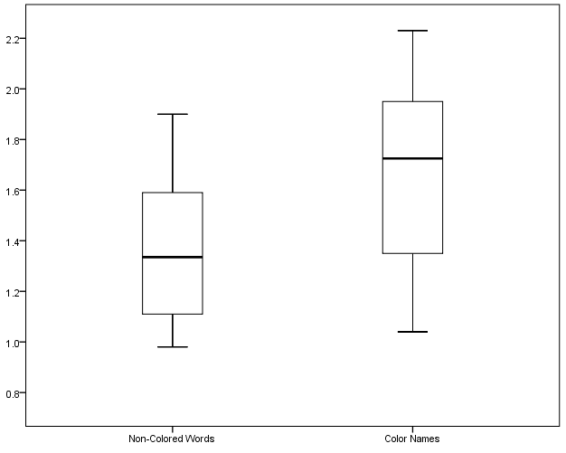
Figure 1. Comparative boxplots for the example class data.

If students are interested in comparing males and females, similar summaries and graphs could be obtained to compare the genders for the color names, or for the non-color words. This could be used for a homework assignment.

IV. Interpret the Results
After calculating the summaries and drawing the boxplots the questions can now be answered.
Students can compare the overall means to see if students were faster, on average, when the words were not color names. If there are outliers, discuss how the outliers may make this comparison less than ideal. Each of the values in the five-number summary can be compared as well as the placement of the boxplots.

Students should follow this discussion with thoughts on how their results may or may not support what the psychology researcher found. If the students in the class tended to be faster with non-color words, can this result be generalized to a larger population? All students? All students of this age? Limitations of the study should also be addressed. One limitation is that the cards were not truly randomized. The cards could be numbered and a computer used to put the numbers, and thus the cards, in random order. Another limitation may be that using students with stopwatches to time such quick responses may not be very accurate, and there will likely be some variability between students with some students tending to stop the timer faster than other students.

Assessment
At a large company, data are collected on employees with respect to the number of years they have worked at the company. Below are numeric summaries and comparative boxplots to compare the times for men and women.

 | Mean | Minimum | First Quartile | Median | Third Quartile | Maximum
Men | 8.0 | 2 | 5.0 | 8.0 | 11.0 | 23
Women | 6.1 | 1 | 3.0 | 6.5 | 9.0 | 13

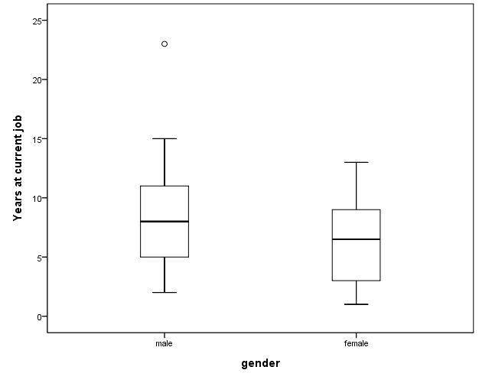

1. Use the numeric summaries to determine if there are any outliers.

2. a. Can we conclude that the times at the company tend to be greater for one of the genders?

b. What can be seen in the numeric summaries to make this conclusion?

c. What can be seen in the boxplots to make this conclusion?

3. (Fill in the blank) The 50% of men who have been with the company the shortest amount of
time have worked there for between years and years.

4. (Fill in the blank) The 25% of the women who have been with the company the longest have
been there for between years and years.

Answers
1. For men, a step = (1.5)*(11-5) = 9. Thus, values less than 5 – 9 = -4 or greater than 11 + 9 = 20 are outliers. Since the maximum value is 23, we see that there is at least one large outlier in the group for men. For women, a step = (1.5)*(9-3) = 9. Thus, values less than 3 – 9 = -6 or greater than 9 + 9 = 18 are outliers. Since the minimum and maximum values are not outside these limits, there are no outliers for this group.

2. a. The men at the company have generally worked there longer.
b. All of the numeric summaries are greater for men than for women, indicating that the number of years recorded for the men tend to be greater than the number of years recorded for the women. Note that since the maximum for men is an outlier, it would be better to compare the maximum value for men that is not an outlier to the maximum for women. However, with only the numeric summaries this is not possible.
c. The comparative boxplots show the boxplot for males is shifted slightly higher than the boxplot for females. Here we can see that the non-outlier maximum for men is greater than the maximum for females.

3. (Fill in the blank) The 50% of men who have been with the company the shortest amount of
time have worked there for between 2 years and 8 years.

4. (Fill in the blank) The 25% of the women who have been with the company the longest have
been there for between 9 years and 13 years.

Possible Extensions (to GAISE Level C)
A paired t-test can be performed to determine if there is a statistically significant difference between the mean response times for the two types of words. A confidence interval for the difference in means with paired data could be constructed to estimate the difference in the mean response times for these types of words. If comparisons are made between males and females for either type of word, an independent samples t-test could be used to check for statistical significance, and a confidence interval could be used to estimate the difference between the mean response times for males and females. For smaller classes, outliers may pose a problem with these techniques, therefore a check for outliers would be especially important before performing these analyses.

A computer version of this activity can be found at
http://economics-files.pomona.edu/statsite/Statgame.html (note: As of October 2015, this URL seems to be broken—sorry).
This website has a program called StatGames that can be downloaded. Along with an activity similar to the activity given here, StatGames contains several other activities that can be used to collect data for statistical analysis.

References
1. Guidelines for Assessment and Instruction in Statistics Education (GAISE) Report, ASA, Franklin et al., ASA, 2007 http://www.amstat.org/education/gaise/

2. Adapted from an activity created by Paul J. Fields, Ph.D. for the American Statistical Association Meeting Within a Meeting Program for Middle School Teachers (2008).
Colors Challenge Activity Sheet
In this activity you will design and participate in an experiment to investigate whether or not the ability to name the color of printed ink is challenged when the word written with the ink is the name of a color.

1. Write some ideas about how we can collect data to see if people tend to have difficulty saying the color of ink used to write a word when the word is the name of a color?

2. Record the times for the students in your group in the table below. After recording all of the times, calculate the average time for non-color words and the average time for color names for each student and write that in the table. After completing your group’s table, have one student record your group’s results in the class table.
Name | Non-Color Words  (seconds) |  | Color Names  (seconds)
 | Average: |  | Average:
 | Average: |  | Average:
 | Average: |  | Average:
 | Average: |  | Average:
3. Complete the table below showing numeric summaries for the two types of words for the class.

 | Mean | Minimum | First Quartile | Median | Third Quartile | Maximum
Non-Color Words
Color Names

4. Determine what values would be considered to be outliers for each of the groups. Are there any outliers?

5. Construct side-by-side boxplots for the two types of ink. Do not use outliers for the minimum or maximum values.

Seconds

Non-Color Words Color Names

6. Are the class results consistent with the results reported by the psychology researcher? Explain.

7. The results obtained are based on data collected only on the students in this class. Is there a larger group to which we could reasonably extend the results?

8. What limitations are there to this study? That is, are there things that could be improved in order to obtain results that may be more reflective of the true values?

Class Recording Sheet

Name | Gender | Non-Color Words Average  (seconds) | Color Names  Average  (seconds)

