How High Can You Jump?  Diann Reischman  Grand Valley State University  reischmd@gvsu.edu  Published: March 2012 | 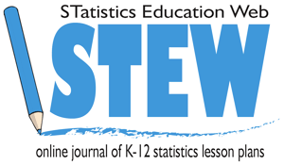

Overview of Lesson
In this activity, students collect data designed to investigate how high students in their class can jump. Students are asked to design an experiment to explore this. Numeric summaries (mean and five-number summary), comparative boxplots, and a scatterplot are used to summarize data collected from the class. Conclusions about jump heights are drawn based on the summaries and graph.

GAISE Components
This investigation follows the four components of statistical problem solving put forth in the Guidelines for Assessment and Instruction in Statistics Education (GAISE) Report. The four components are: formulate a question, design and implement a plan to collect data, analyze the data by measures and graphs, and interpret the results in the context of the original question. This is a GAISE Level B activity.

Common Core State Standards for Mathematical Practice
- Make sense of problems and persevere in solving them.
- Reason abstractly and quantitatively.
- Construct viable arguments and critique the reasoning of others.
4. Model with mathematics.
5. Use appropriate tools strategically.

Common Core State Standard Grade Level Content (High School)
S-ID. 1. Represent data with plots on the real number line (dot plots, histograms, and box plots).
S-ID. 2. Use statistics appropriate to the shape of the data distribution to compare center (median, mean) and spread (interquartile range, standard deviation) of two or more different data sets.
S-ID. 3. Interpret differences in shape, center, and spread in the context of the data sets, accounting for possible effects of extreme data points (outliers).
S-IC. 1. Understand statistics as a process for making inferences about population parameters based on a random sample from that population.

NCTM Principles and Standards for School Mathematics
Data Analysis and Probability Standards for Grades 9-12
Formulate questions that can be addressed with data and collect, organize, and display relevant data to answer them:
- know the characteristics of well-designed studies, including the role of randomization in surveys and experiments;
- understand the meaning of measurement data and categorical data, of univariate and bivariate data, and of the term variable;
- understand histograms, parallel box plots, and scatterplots and use them to display data;
- compute basic statistics and understand the distinction between a statistic and a parameter.
Select and use appropriate statistical methods to analyze data:
- for univariate measurement data, be able to display the distribution, describe its shape, and select and calculate summary statistics;
- display and discuss bivariate data where at least one variable is categorical.
Prerequisites
Students will have knowledge of calculating numeric summaries for one variable (mean and five-number summary). Students will have knowledge of how outliers may affect numeric summaries. Students will have knowledge of how to construct and interpret scatterplots and comparative boxplots.

Learning Targets
Students will have a basic understanding of how to design a study to collect data. Students will be able to calculate numeric summaries and construct a scatterplot and comparative boxplots. Students will be able to determine what data values would be considered to be outliers. Students will be able to compare two data sets using their calculated numeric summaries and comparative boxplots, and students will be able to look at a scatterplot to draw conclusions about a possible relationship between two quantitative variables.

Time Required
One class period.

Materials Required
- Tape measures
- Tape
- Pencils
- Graphing calculators
- Activity sheet for data collection (this is on page 10)

Instructional Lesson Plan

The GAISE Statistical Problem-Solving Procedure

I. Formulate Question(s)
Begin the lesson by discussing the nature of the study. Tell the students that it is of interest to explore how high students in their class can jump, and that they will be designing a study to collect data to investigate this. Ask students to write some questions that they feel would be useful to answer.

Some possible questions they may ask:
1. What is the average height a student in their class can jump?
2. Can one gender jump higher than the other?
3. Can taller students jump higher?

II. Design and Implement a Plan to Collect the Data
Tell the students that they will be collecting data from students in the class to answer these questions. Ask students to think about how they could collect this data. Some possible things they should consider:
1. How can they obtain an accurate height for each student?
2. Should they measure height with or without shoes?
3. Are there restrictions on how a student may jump, such as only standing jumps are valid or both feet must be on the floor at the start of the jump?
4. How can they measure how high a student can jump?
5. How many jumps does each student get to try?
After discussion of possible ways to collect the data, explain how the data will be collected in the classroom.

Break the students into groups of at least four students. Give each group a tape measure, roll of tape, data collection sheet, a pencil, and a graphing calculator. A vertical jump test will be used to determine how high a student can jump. The vertical jump test measures the difference between the standing reach height and the height reached with a vertical jump. A tape measure taped to the wall can be used to measure the student’s height, standing reach height, and jumping reach height, in inches. Students should know how to use the calculator to convert fractions of an inch in the height measurements to decimal numbers since fractions are not desirable for the data analysis.

One student stands with both feet flat on the ground next to the wall with the tape measure. Another student looks at the tape measure to determine the student’s (standing) height, and this is recorded in the data collection sheet. Next, the student extends his arm up to show how far he can reach. This is the student’s standing reach height and is recorded in the data collection sheet.

Now the student then keeps his arm reaching up and jumps, touching the wall near the tape measure at the top of the jump. Two students watch the tape measure to determine how high the student’s fingers reach during the jump. This height is the student’s jumping reach height and is recorded in the data collection sheet.

Each student should get a few practice jumps. When official measuring starts, each student gets three tries. The highest jump height of the three is recorded. Alternatively, an average may be used as the student’s jump height. The final jump height for the student is calculated as (maximum jumping reach height – standing reach height).

Once data have been collected for all students in the group, students record their results on a class data collection sheet (provided on the Activity Worksheet on page 14).

III. Analyze the Data
There are three main parts of this study. First, it is of interest to investigate how high students in their grade can jump. Ask students what numbers can be calculated in order to describe how high the students jumped.

Second, it is of interest to determine if the boys can jump higher than the girls. Ask students what numbers can be calculated or what graphs can be drawn in order to help make this determination.

Third, it is of interest to determine if there is a relationship between a student’s height and how high he or she can jump. Ask students what numbers can be calculated or what graphs can be drawn in order to investigate such a relationship.

After the discussion, ask students to find the mean and the five-number summary for the jump heights overall and broken into the girls and boys. Below is a table of example summaries, in inches.

 | Mean | Minimum | First Quartile  (Q1) | Median | Third Quartile  (Q3) | Maximum
Entire Class | 9.66 | 5.13 | 7.50 | 9.88 | 11.50 | 14.00
Girls | 9.44 | 5.13 | 7.75 | 9.75 | 11.94 | 13.50
Boys | 9.87 | 6.75 | 7.94 | 9.75 | 11.72 | 14.00

After finding the five-number summary, ask students to determine if there are any outliers in any of the data sets. These are determined by first calculating the interquartile range (IQR) as IQR = Q3 – Q1. A step for outliers is 1.5 times the IQR, i.e., step=(1.5)(IQR). Any data values more than one step below Q1 or more than one step above Q3 are considered outliers. Based on the summaries in the table above, a step in the overall class would be equal to (1.5)*(11.50-7.50) = 6.00. Thus, values greater than 11.50 + 6.00 = 17.50 would be outliers, and values less than 7.50 – 6.00 = 1.50 would be outliers. For the girls, it can be shown that values less than 1.46 and values greater than 18.23 would be outliers; and for the boys it can be shown that values less than 2.27 and values greater than 17.39 would be outliers. For the three data sets summarized in the above table, there are no outliers.

Next the students can create the comparative boxplots from the five-number summaries for the girls and the boys. It is better not to use outliers for the minimum and maximum values for the whiskers of the boxplots. If the students found any outliers, they should look at the class data sheet to determine what the maximum and minimum values would be without the outliers. These data values would be used as the maximum and minimum for the whiskers of the boxplots. The outlier would then be plotted as a separate point.

Figure 1 below shows the boxplots for the summaries for girls and boys in the table above.

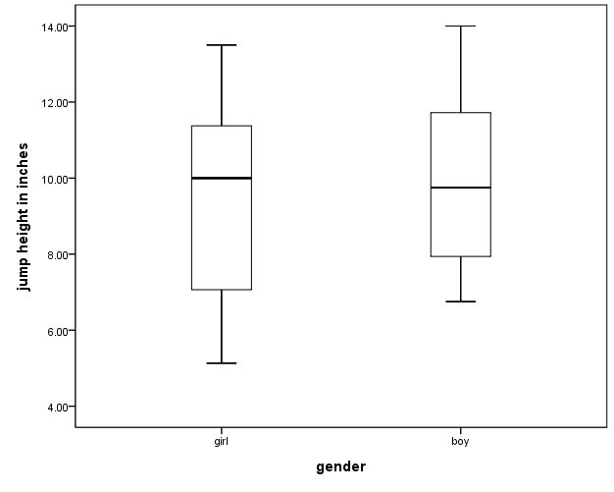
Figure 1. Boxplots comparing jump heights for boys and girls.

To investigate a possible relationship between height and jump height, students can create a scatterplot. Students should first determine which variable would be considered the independent variable and which would be considered the dependent variable. Figure 2 below shows the scatterplot for the example data set.

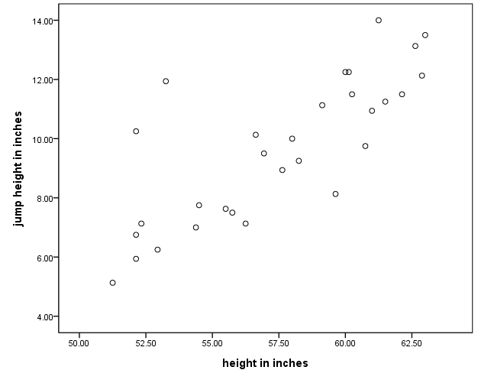
Figure 2. Scatterplot showing the relationship between height and jump height.

IV. Interpret the Results
After calculating the summaries and drawing the boxplots and scatterplot, answers to questions of interest can now be discussed.

Students can examine the overall numeric descriptives to describe how high the students in their class can jump. The separate numeric descriptives, along with the comparative boxplots, can be used to compare the girls and boys in the class. The scatterplot can be examined for a possible relationship between height and jump height. If a relationship is visible in the scatterplot a discussion about the type of relationship can follow. For example, does the scatterplot show taller students tend to be able to jump higher? And, if so, how much higher?

After discussing the results for the class, students should think about whether their results might be extended to a larger group. Do they think it is possible that if another class in their grade collected this type of data they would get similar results? Would students in the same grade at a different school get similar results? Would students in a higher or lower grade get similar results?

Assessment
1. Data are collected on the number of minutes students spent on homework during one week. Below are numeric summaries and comparative boxplots to compare the number of minutes spent on math homework and science homework.

 | Mean | Minimum | First Quartile | Median | Third Quartile | Maximum
Math | 93.25 | 60.0 | 80.0 | 95.5 | 110.0 | 120.0
Science | 81.00 | 50.0 | 60.5 | 75.0 | 110.0 | 120.0

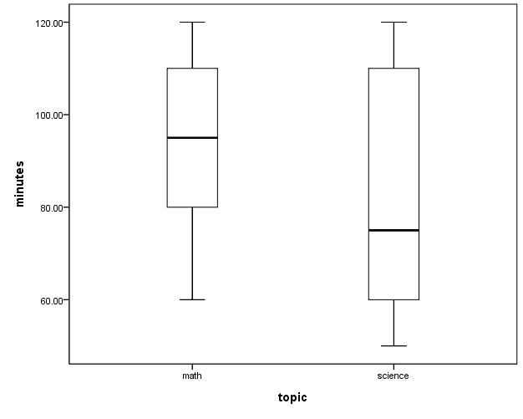

a. Use the numeric summaries to determine if there are any outliers.

b. Can we conclude that the amount of time spent on homework tended to be greater for one of these subjects compared to the other? Explain what is seen in the numeric summaries and boxplots that lead to your conclusion.

c. (Fill in the blank) Fifty percent of these students spent ____________ minutes or more on math homework.

d. (Fill in the blank) Twenty-five percent of these students spent _______________ minutes or less on science homework.
2. Data are collected to investigate a possible relationship between the number of minutes students in a particular class spent studying for a social studies test and the number of points (out of a possible 100) received on the test. Below is a scatterplot for the collected data.

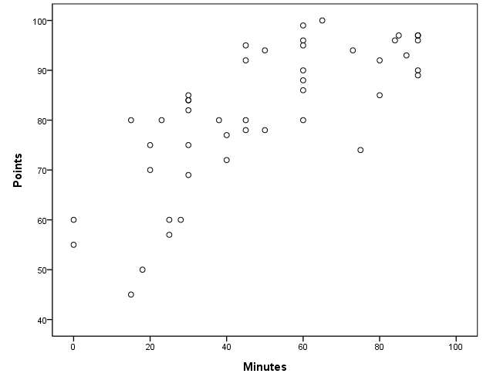
a. What kind of pattern is seen in the scatterplot (straight line relationship, or curved relationship)?

b. Does the scatterplot show a positive or negative relationship between the two variables? Explain what this means in terms of the application.

Answers
1. For math, step = (1.5)*(110-80) = 45. Thus, values less than 80 – 45 = 35 or greater than 110 + 45 = 155 are outliers. Since the minimum and maximum values are not outside these limits, there are no outliers for this group. For science, step = (1.5)*(110-60.5) = 74.25. Thus, values less than 60.5 – 74.25 = -13.75 or greater than 110 + 74.25 = 184.25. Since the minimum and maximum values are not outside these limits, there are no outliers for this group.

2. The students tended to spend more time on math homework than on science homework. The third quartiles and maximum values are the same for the two subjects, but for all other measures (mean, minimum, first quartile, and median) the number of minutes is higher for math. Looking at the boxplots, the top whiskers are the same but otherwise the math boxplot shows values higher than the science boxplot.

3. (Fill in the blank) Fifty percent of these students spent 95.5 minutes or more on math homework.

4. (Fill in the blank) Twenty-five percent of these students spent 60.5 minutes or less on science homework.

5. a. The pattern is fairly straight for the lower number of minutes, but shows some curvature as the number of minutes increases.
b. There is a positive relationship. This means that as the number of minutes studied increases, the score on the test tends to increase.

Possible Extensions (to GAISE Level C)
A t-test can be performed to determine if there is a statistically significant difference between jump heights for females and males. A confidence interval could also be used to compare the jump heights for females and males. Simple linear regression methods can be used with the scatterplot to create a model to predict jump heights based on heights.

References
1. Guidelines for Assessment and Instruction in Statistics Education (GAISE) Report, ASA, Franklin et al., ASA, 2007 http://www.amstat.org/education/gaise/

2. This activity is based on the activity by Tim Burgess, titled How high can you jump? On the Census at School website http://www.censusatschool.org.nz/.

How High Can You Jump Activity Sheet

1. Write some ideas about how the class can collect data to determine how high the students can jump.

2. Record the height, standing reach height, and jumping reach height for each student in the group. Calculate the difference between the (maximum) jumping reach height and standing reach height to obtain the jump height. After three tries, record the maximum jump height.

Name | (Standing)  Height | Standing Reach Height | Jumping Reach Height | Jump Height*
*Jumping Height = Maximum Jumping Reach Height – Standing Reach Height

3. Complete the table below showing numeric summaries for jump heights for the entire class, and for the separate groups for girls and boys.
 | Mean | Minimum | First Quartile  (Q1) | Median | Third Quartile  (Q3) | Maximum
Entire Class
Girls
Boys

4. Determine what values would be considered to be outliers for each of the groups. Are there any outliers?

5. Construct side-by-side boxplots for jump heights for girls and boys. Do not use outliers for the minimum or maximum values.

Jump Height

Girls Boys

What conclusions can be drawn from the comparative boxplots?

6. Construct a scatterplot for the heights and jump heights for the entire class. Label each axis with the appropriate variable name.

What type of relationship between height and jump height, if any, does the scatterplot show?

7. The results obtained are based on data collected only on the students in this class. Are there any other groups that we might expect to get similar results? Are there are larger groups to which we could extend the results?

8. What limitations are there to this study? That is, what are some things that could be improved upon in this study?

Class Recording Sheet

Name | Gender | Height | (Maximum)  Jump Height

