|  |  |
| --- | --- |
| **Spinners at the School Carnival**  **(Equal Sections)**  Janis Carthon  Albany State University  [janis.carthon@asurams.edu](mailto:dhydorn@umw.edu)  **Published: February 2012** | **C:\Users\hstohl\Desktop\JournalEditorialWork\STEW\Website\STEW_logo.gif** |

**Overview of Lesson**

This investigation focuses on guiding students as they collect and interpret data from a spinner experiment with outcomes that are equally likely. Students will have the opportunity to organize the collected data in tables and graphs and will draw conclusions and make predictions based on the data collected.

**GAISE Components**

This investigation follows the four components of statistical problem solving put forth in the *Guidelines for Assessment and Instruction in Statistics Education (GAISE) Report*. The four components are: formulate a question, design and implement a plan to collect data, analyze the data by measures and graphs, and interpret the results in the context of the original question. This is a GAISE Level A activity.

**Common Core State Standards for Mathematical Practice**

1. Make sense of problems and persevere in solving them.

4. Model with mathematics.

**Common Core State Standard Grade Level Content (Grades 3 through 5)**

3. MD. Represent and interpret data.

**NCTM Principles and Standards for School Mathematics**

**Data Analysis and Probability Standard for Grades 3-5**

**Formulate questions that can be addressed with data and collect, organize, and display relevant data to answer them:**

* design investigations to address a question and consider how data-collection methods affect the nature of the data set;
* collect data using observations, surveys, and experiments;
* represent data using tables and graphs such as line plots, bar graphs, and line graphs.

**Select and use appropriate statistical methods to analyze data:**

* describe parts of the data and the set of data as a whole to determine what the data show.

**Prerequisites**

Students will have knowledge of how to construct frequency tables and bar graphs.

**Learning Targets**

Students will be able to organize the results of a probability experiment in a frequency table. Students will be able to summarize the results of a probability experiment. Students will be able to make predictions based on the results of a probability experiment. Students will become aware that the more they repeat an experiment the more reliable their results will be.

**Time Required**

One class period.

**Materials Required**

Equal spinner with 4 sections (copy master attached on **page 9**), large paper clips, scissors.

**Instructional Lesson Plan**

**The GAISE Statistical Problem-Solving Procedure**

**I. Formulate Question(s)**

Begin the lesson by formulating a hypothetical scenario: At the school carnival, there is a game where students spin a spinner. The spinner has four equal sections (see Figure 1). Three of the sections (red, green, blue) represent a colored toy car and the fourth section is yellow representing no toy car. You win the colored toy car the spinner stops on. If the spinner lands on yellow, then no car is won. The parents responsible for organizing this carnival game want to know how many of each colored toy car they must buy if they are expecting about 200 students to play the game.

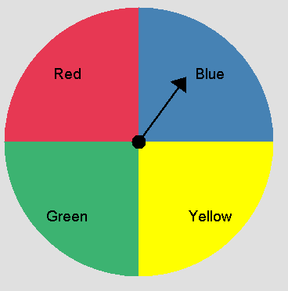

Figure 1. The spinner.

**II. Design and Implement a Plan to Collect the Data**

Explain to the class that they will conduct an experiment to help determine how many of each colored toy car parents must buy if they are expecting about 200 students to play the spinner game at the carnival. Display the spinner with the four equal sections labeled red, green, blue, and yellow. Ask students: Where have you seen spinners? What did they look like? What are ways spinners are used?

Ask students: What can happen when you spin the spinner? Could you ever get a yellow car? Why or why not? What is the chance of spinning the spinner and it landing on a red car? Will you always get a red car? The goal is to generate the sample space, which is {red car, green car, blue car, no car}, and to have students begin to understand that since the sections in this spinner are equal the outcomes in the sample space are equally likely.

Model the correct way to use the spinner. Use a large paper clip as the spinner. Unfold on the outer loop of the paper clip so that one end is still enclosed by a loop. Place your pencil through the looped end and hold it on the center of the spinner. Use your finger to flick the extended paper clip. Give each student a copy of the spinner and a large paper clip. Have students create their spinner and practice spinning. You may wish to have students tape their spinner to their desk or table. The spinner should be on a flat surface.

Ask students: If the game were played 20 times, about how many of each colored toy car do you think will be given away? How many times will no car be given away? Is it more likely to land on green than blue? Is it less likely to land on yellow? The goal is for students to realize that this is a fair spinner. The chance of landing on each section is the same so they are dividing the total number of spins by 4 to find the expected number for each color. After students’ responses, suggest that they play the game with their own spinner.

Give each student a recording sheet with a frequency table (see Table 1). Spin the spinner and demonstrate how to make a tally mark on the frequency table. Have each student spin the spinner 10 times and record each spin with a tally mark and record the frequency on the table.

Table 1. Individual student frequency table.

|  |  |  |
| --- | --- | --- |
| **Color** | **Tally** | **Frequency** |
| Red |  |  |
| Green |  |  |
| Blue |  |  |
| Yellow |  |  |

**III. Analyze the Data**

Place the students in pairs. Ask students to compare the results in their frequency table with their partners’ results. Were the results the same or different? Why do you think all of the results were not the same? What conclusions can you make after 20 spins (10 spins per student)?

Place the students in groups of four. Tell the students that they are going to combine each of the group member’s results into one table for the group. Before they begin ask students what the total number of spins will be for their group. The total number of spins for each group is 40. How many of each color do you think the group will have? Explain what the expected results are for each color after 40 spins. Were the results as expected? Why or why not? Encourage students to see that the spinner should have landed on each color about 10 times.

Give each group a frequency table and have the students record their group data on the table. Ask the groups to compare their data with the individual results for 10 spins and the paired results for 20 spins. Give each group grid paper. Each group should create a bar graph of the group’s data. Demonstrate how to organize the scales on the grid paper as shown below.



Figure 2. Scales for group bar graph.

After each group has constructed a bar graph ask them to share their bar graph with other groups. Stress to students that the group results are different but the height of the bar for each color is about 10.

Collect class data in another frequency table. There should be 200 total spins for the class. Display a table with class data to examine the results of all the spins. An example of class data by groups is shown in Table 2. (Results generated by using TinkerPlots)

Table 2. Example class data by groups.

|  |  |  |  |  |  |  |
| --- | --- | --- | --- | --- | --- | --- |
| **Color** | **Group 1**  **Frequency** | **Group 2**  **Frequency** | **Group 3**  **Frequency** | **Group 4**  **Frequency** | **Group 5**  **Frequency** | **Class**  **Total** |
| Red | 14 | 7 | 12 | 15 | 10 | 58 |
| Green | 7 | 13 | 8 | 10 | 10 | 48 |
| Blue | 11 | 9 | 10 | 7 | 7 | 44 |
| Yellow | 8 | 11 | 10 | 8 | 13 | 50 |

Construct a bar graph of the class results. Ask students: What happened as the number of spins increases from 10 to 20 to 40 to 200? Discuss that the results stabilize to the expected numbers as the number of repetitions increases.

**IV. Interpret the Results**

Facilitate a summary discussion and return to the motivating question. Ask students in their groups to discuss the answer to the question. Stress that the group needs to determine how many of each color toy car the parents should buy. Have each group share their responses. After each group presentation, ask if 200 students play the game about how many of each toy car will be given away and about how many students will not win a toy car? The students should give a reason for their answers.

**Assessment**

Students in Ms. Smith’s class asked 40 students at their school to spin the spinner below. A student won a small prize if the spinner stopped in the section labeled “Yellow.”

Yellow White

Blue Red

Green Black

Purple Pink

About how many times would you predict the spinner would stop in the section labeled Yellow?

Use words, numbers, and/or a drawing and explain how you made your prediction for the number of times the spinner would stop in Yellow out of 40 spins.

**Answer**

We would expect the spinner to stop in the section labeled Yellow about 5 times. For a fair spinner, each section has the same chance. Divide the total number of spins by number of sections: 40/8 = 5.

**Possible Extensions**

Change the number of students who will play the game to 400. Ask students how many toy cars need to be ordered. Have students go to the website: <http://illuminations.nctm.org/activitydetail.aspx?ID=79>. At this website students can create a spinner with four equal sections and then spin the spinner a large number of times. Students should record the results in a frequency table and a bar graph and then draw conclusions as to how many toy cars need to be purchased.

**Resources**

1. *Guidelines for Assessment and Instruction in Statistics Education* (GAISE) Report, ASA, Franklin et al., ASA, 2007 <http://www.amstat.org/education/gaise/>

2. *Illuminations: Adjustable Spinner*. Retrieved January 5, 2012, from National Council of Teachers of Mathematics: <http://illuminations.nctm.org/activitydetail.aspx?ID=79>

3. Konold, C. and Miller, C. D. TinkerPlotsTM Dynamic Data Exploration [Computer software]. Available from http://www.keypress.com

4. Website: <http://nlvm.usu.edu/en/nav/vlibrary.html> (Adjustable Spinner in Data Analysis & Probability grades 3-5.)

5. Related to Investigation 6.4: How Many Spins to Win the Prize? of the ASA module Bridging the Gap written by Pat Hopfensperger, Tim Jacobbe, Deborah Lurie, and Jerry Moreno (2012).

**Spinners at the School Carnival Activity Sheet**

At the school carnival there is a game where students spin a spinner. The spinner has four equal sections. Three of the sections (red, green, blue) represent a colored toy car and the fourth section is yellow representing no toy car. You win the colored toy car the spinner stops on. If the spinner lands on yellow, then no car is won. The parents responsible for organizing this carnival game want to know how many of each colored toy car they must buy if they are expecting about 200 students to play the game.

**1.** About how many of each colored toy car do you think will be given away if the game was played 20 times? Why?

**2.** About how many times would no car be given away if the game was played 20 times? Why?

**3.** Spin the spinner 10 times and record each result with a tally mark on the frequency table.

|  |  |  |
| --- | --- | --- |
| **Color** | **Tally** | **Frequency** |
| Red |  |  |
| Green |  |  |
| Blue |  |  |
| Yellow |  |  |

**4.** Combine the results in your frequency table with your partner’s results.

|  |  |  |
| --- | --- | --- |
| **Color** | **Tally** | **Frequency** |
| Red |  |  |
| Green |  |  |
| Blue |  |  |
| Yellow |  |  |

Were your results the same as or different from your partner?

Why do you think the results were not the same or different?

**5.** Combine the results in your frequency table with the members of your group.

What is the total number of spins for the group?

How many of each color do you think the group will have?

|  |  |  |
| --- | --- | --- |
| **Color** | **Tally** | **Frequency** |
| Red |  |  |
| Green |  |  |
| Blue |  |  |
| Yellow |  |  |

On the grid below, create a bar graph of the group data.

**Group Bar Graph**

**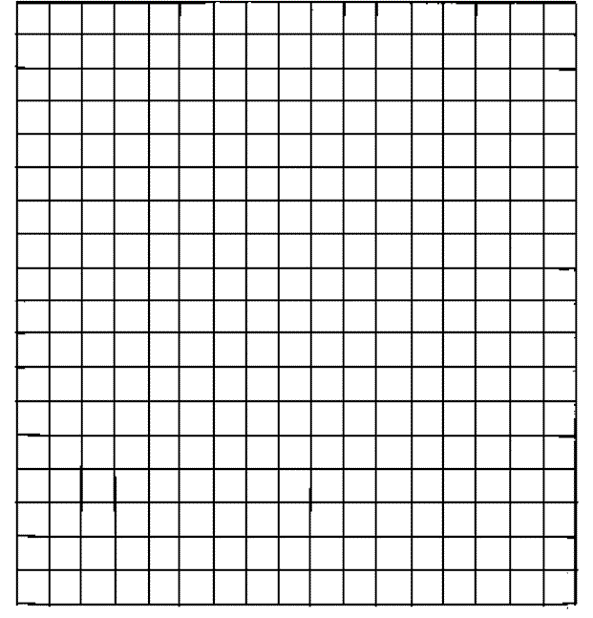**

**6.** Copy the class results into the table below.

**Spinner Results for Class**

|  |  |  |  |  |  |  |
| --- | --- | --- | --- | --- | --- | --- |
| **Color** | **Group 1**  **Frequency** | **Group 2**  **Frequency** | **Group 3**  **Frequency** | **Group 4**  **Frequency** | **Group 5**  **Frequency** | **Class**  **Total** |
| Red |  |  |  |  |  |  |
| Green |  |  |  |  |  |  |
| Blue |  |  |  |  |  |  |
| Yellow |  |  |  |  |  |  |

On the grid below, create a bar graph of the class data.

**Class Bar Graph**

****

How many times do you think the spinner will land on each color if the game was played 200 times?

**Spinner**

green

blue

yellow

red